**Recipe: 2**

**Masala Chana** - Brown Bengal gram are known for its nutritional goodness and when served as a chaat it will be irresistible

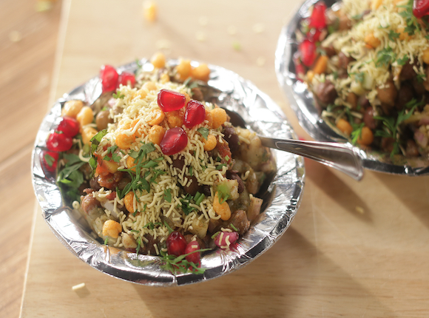

History of Indian cuisine dates back to nearly 5,000-years ago when various groups and cultures interacted with India that led to a diversity of flavours and regional cuisines.

Indian cuisine comprises of a number of regional cuisines. The diversity in soil type, climate, culture, ethnic group and occupations, these cuisines differ from each other mainly due to the use of locally available spices, herbs, vegetables and fruits. Indian food is also influenced by religious and cultural choices and traditions.

Foreign invasions, trade relations and colonialism had introduced certain foods to the country like potato, chillies and breadfruit.

**Prep Time : 7-8 hour**

**Cook time : 0-5 minutes**

**Serve : 2**

**Level Of Cooking : Easy**

**Taste : Tangy**

**Ingredients for Masala Chana Recipe**

1. Brown Bengal gram (kala chana) 1 1/2 cups
2. Small potatoes boiled and peeled 2
3. Small onion chopped 1
4. Small tomato chopped 1
5. Green chillies chopped 1-2
6. Roasted cumin powder 1 teaspoon
7. Chaat masala 1 1/2 teaspoons
8. Salt to taste
9. Fresh coriander leaves chopped 1 tablespo to garnish
10. Raw mango chopped 2 teaspoons
11. Green chutney 1 1/2 tablespoons
12. Date and tamarind chutney 1 1/2 tablespoons
13. Red chilli-garlic chutney 1 tablespoon
14. Masala boondi to garnish
15. Masala chana to garnish
16. Sev to garnish
17. Fresh pomegranate pearls to garnish

Method

Step 1

Take boiled brown chickpeas in a bowl, mash the potatoes and add along with onion, tomato, green chillies, roasted cumin powder, chaat masala, salt, coriander leaves, raw mango, green chutney, date and tamarind chutney and red chilli-garlic chutney and mix well.

Step 2

Transfer into individual serving bowls, garnish with masala boondi, masala chana dal, sev, coriander leaves and pomegranate pearls. Serve immediately.